2025 UNNC Robot Olympics
Hosted by the Faculty of Science and Engineering
Date: 21st November 2025
Venue: UNNC Sports Centre, CSIAED Conference, University of Nottingham Ningbo China
Contact: Adam Rushworth (M3 Department)


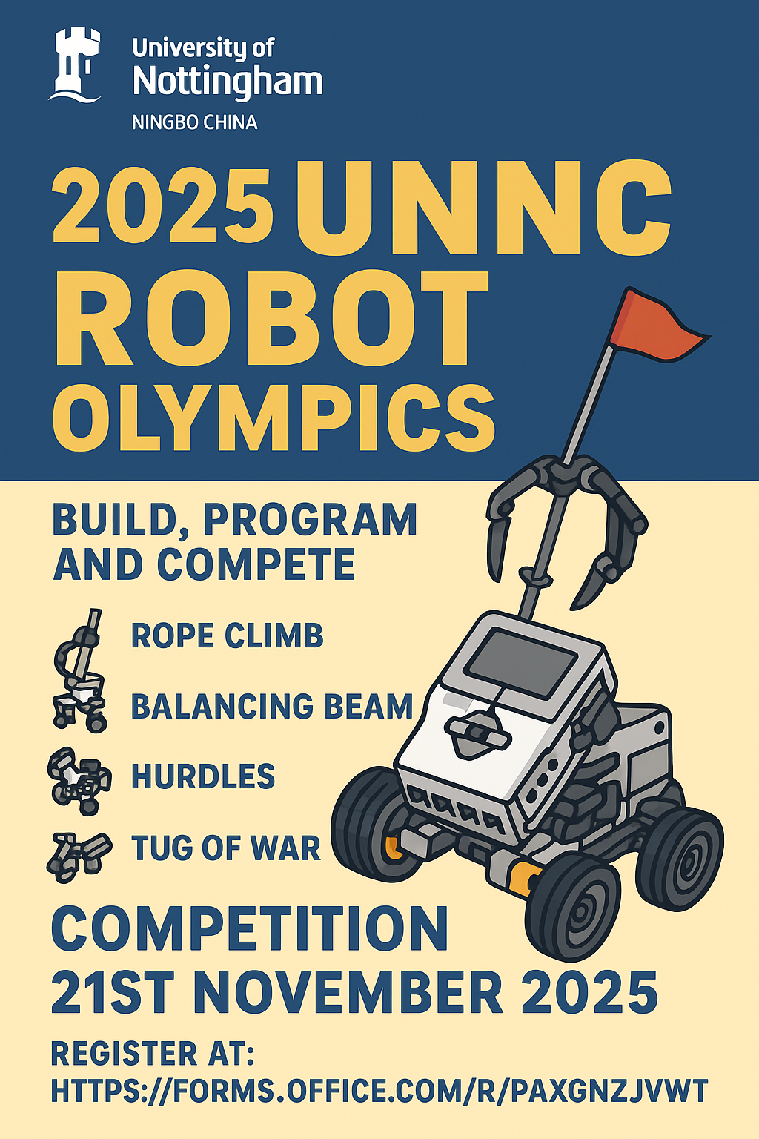
Find out more
Find

Register

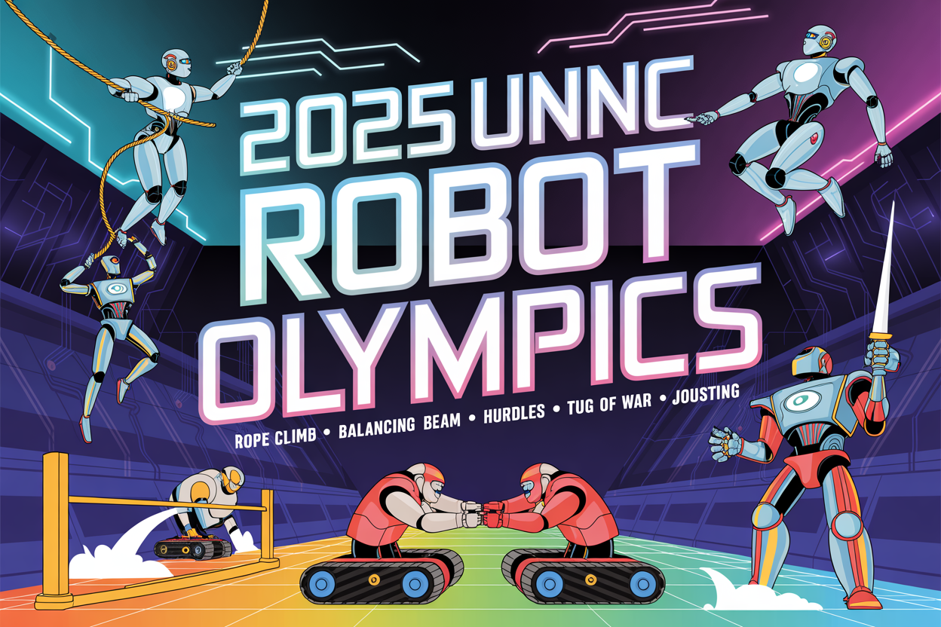

1. Theme Overview
The 2025 UNNC Robot Olympics challenges participants to design and build a single autonomous robot capable of competing in multiple athletic-style events. Each challenge tests a different mechanical and programming skill, promoting creativity, engineering precision, and teamwork.
- Each entry (team or individual) must build one robot to compete across all challenges.
- Participants may use a Lego Mindstorms EV3 set provided by the Faculty (issued from the library). Use of the EV3 kit is encouraged but not compulsory.
- Robots must be autonomous and pre-programmed. Remote control or live teleoperation during any challenge is strictly prohibited.
- The same robot design must compete in all events (modifications between events are allowed, provided they occur within scheduled preparation times).

2. Participation
- Eligibility
  - Open to Undergraduate (UG) and Postgraduate (PG) students of UNNC.
  - Open to all Preliminary Year students.
  - UG participants in years 2-4 must be registered in the Department of Mechanical, Materials and Manufacturing Engineering (M3) — including Mechanical Engineering, Product Design and Manufacture, and Aerospace Engineering.
- Team Composition
  - Entries may be individual or team-based (maximum 4 members per team).
  - Teams must nominate a Team Leader for communications and submissions.
- Entry and Selection
  - Participant slots are limited. In the case of oversubscription, team entries will be prioritised.
  - The selection panel reserves the right to shortlist entries based on application quality.
- Registration
  - All participants must complete the MS Forms registration by 31st October 2025: https://forms.office.com/r/paxgNzJVwT

3. Key Dates and Agenda
Date | Activity
31 Oct 2025 | Registration closes
3 Nov 2025 | Notification of successful applicants
6 Nov 2025 | EV3 kits available for issue from the Library
21 Nov 2025 | Competition Day (CSIAED Conference)
21 Nov 2025 (afternoon) | Awards Ceremony

4. Competition Events and Rules
Each robot will compete in five challenges. Teams may modify robots between events within preparation times (~15 mins).

Rope Climb
• Climb a 30 mm diameter rope vertically, carrying own weight.
• Start from rest at the base of the rope.
• Timer stops at 1.5 m height.
• 2-minute limit; highest climb used if not complete.
• Scoring: Speed (6), Stability (2), Design ingenuity (2).

Balancing Beam
• Cross a 20 mm wide, 1 m beam without falling.
• 3 attempts allowed; fastest successful run wins.
• Scoring: Completion/time (6), Stability (2), Creativity (2).

Hurdles
• Navigate a 1.5 m track with 50 mm hurdles.
• Penalties: +3 seconds for wall/hurdle contact.
• Scoring: Completion/time (6), Accuracy (2), Efficiency (2).

Tug of War
• Two robots pull opposite ends of a 30 mm rope.
• Victory: pull opponent over centre line within 2 min.
• Scoring: Match win (6), Grip/traction (2), Consistency (2).

Jousting
• Strike opponent’s 100 mm target plate using a mounted lance.
• Arena: 1.5 m × 1.5 m. 2-minute matches.
• Scoring: Hit accuracy (5), Stability (3), Robustness (2).

5. Judging and Scoring
• Each event contributes up to 10 points for a total of 50.
• The highest total determines the winner.
• Non-participation in an event yields zero but no disqualification.
• Ties resolved by aggregate time performance.
• Judges’ decisions are final.

6. Awards
Category | Prize | Notes
UG 1st Prize | Bambu Labs A1 3D Printer | Guaranteed place(s) in Robotics FURP project
UG 2nd Prize | Robot Dog Building Kit | Guaranteed place(s) in Robotics FURP project
UG 3rd Prize | WALL·E Robot Kit | Guaranteed place(s) in Robotics FURP project
PG 1st Prize | Conference Grant | —

7. Inquiries
For all inquiries, see:
UNNC 2025 Robot Olympics Forum | Group Chat | Microsoft Teams
Supporting staff: 1 × PhD Student (TBC)

8. Support and Resources
Budget Summary:
Item | Purpose | Link | Unit Price (RMB) | Qty | Total (RMB)
Bambu Labs A1 3D Printer | UG 1st Prize | tmall.com | 2000 | 1 | 2000
Robot Dog Kit | UG 2nd Prize | tmall.com | 900 | 1 | 900
WALL·E Robot Kit | UG 3rd Prize | tmall.com | 516 | 1 | 516
Conference Grant | PG 1st Prize | — | — | 1 | —
Event Materials | Obstacles, props, track construction | Various | — | — | 8000

Staff Resource List
Event Chair (Adam Rushworth): Oversight, judging coordination, liaison with CSIAED organisers
Technical Coordinator (PhD Student TBC): EV3 setup, safety checks, troubleshooting
Judges (3): Timing, rule enforcement, scoring
Student Volunteers (4–6): Setup, reset events, crowd management
Admin Support: Certificates, participant registration, kit issuing

