**Ningbo Digital Library (NBDL) User Guide**

for UNNC Users

The NBDL portal address is <https://www.nbdlib.cn/portal>.

There are two ways for you to access the resources.

1. If you are in teaching area on campus, you can direct access to many resources
2. If you are off campus or not in teaching area, you can

* log on to university network environment via VDI service

vdi.nottingham.edu.cn (for staff)

* or request for document delivery on NBDL website (for staff and students)

## Use NBDL document delivery service while off campus

Step 1. Sign in

* Check with UNNC Library or Ningbo University Zone Library about your account information.

UNNC Library [library@nottingham.edu.cn](mailto:library@nottingham.edu.cn)

Ningbo University Zone Library: 0574 8812 6500

* Log on to NBDL <https://www.nbdlib.cn/portal>
* Click ‘登录’to sign in

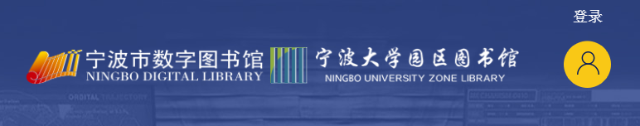

* Select ‘宁波大学园区图书馆’ and fill into your account information

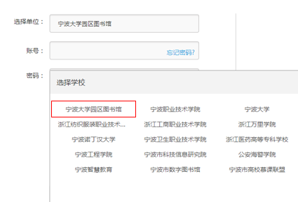

Step 2. Search

* Choose the material type ‘图书’，‘期刊’ or other
* Type into keywords
* Start search by clicking ‘中文搜索’ or ‘外文搜索’

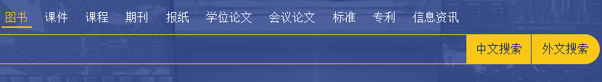

* If you cannot find what you need, please try to search in ‘读秀’as below

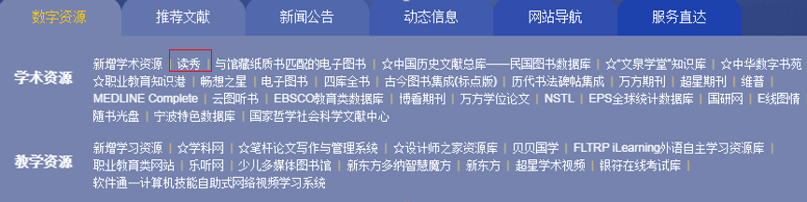

Step 3 Request

* For e-book resource
* Click ‘图书馆文献传递’

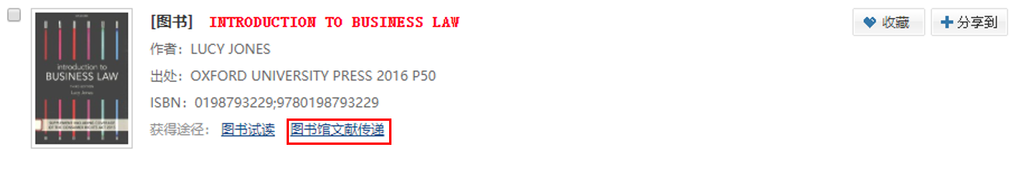

* Fill the page number and your email address (The maximum of 50 pages is allowed to request each time).

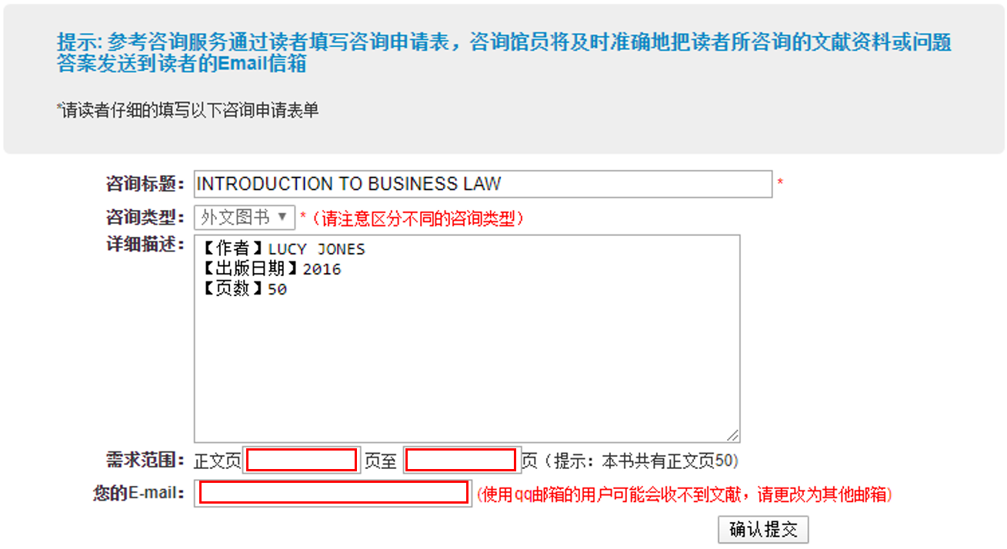

* For article resource
* Click ‘文献传递’

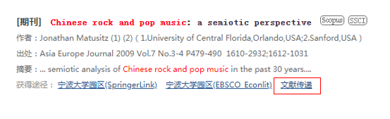

* Fill your email address and submit the request online. You will receive the full text of article from Ningbo Digital Library by email if the article is available.

